**COMP9032 Project Design Menu**

Zihan, Lai ZID:5189667

1. **Introduction**

This project simulates Cup and Ball game on the board. Cup and Ball is an online game where a ball is shuffled under three cups and you guess the position of the ball. For each guess, you gain one point if it is correct or lose one point if it is wrong.

In this simulation system, the push button (PB0) is used to start the game. Three LEDs (LED9, LED8 and LED7) are used to represent the three cups, and these LEDs together with the motor are also used to indicate the ball shuffling among the three cups. The keypad is used for the player to make a guess (only 1, 2, 3 is valid). The player’s score is displayed on the LCD.

For the LED bar on the lab board, two groups of LEDs are used. Three LEDs, called cup LEDs, are associated with three cups (as mentioned before) and the four LEDs (LED5, LED4, LED3, LED2) of the other group work as a result indicator for a guess. When a guess is correct, the indicator will flash.

When the player wants to make a guess for the ball position by pressing the push button again, the ball shuffle stops. In this case, if the player’s guess is correct, the score on the LCD is incremented by 1 and the indicator will flash a few times, otherwise, the score on LCD is decremented.

When the player’s score becomes zero, the game will be reset to the initial start status; otherwise, the game can be continued by pressing the button for a new round of ball shuffle.

1. **Diagram**

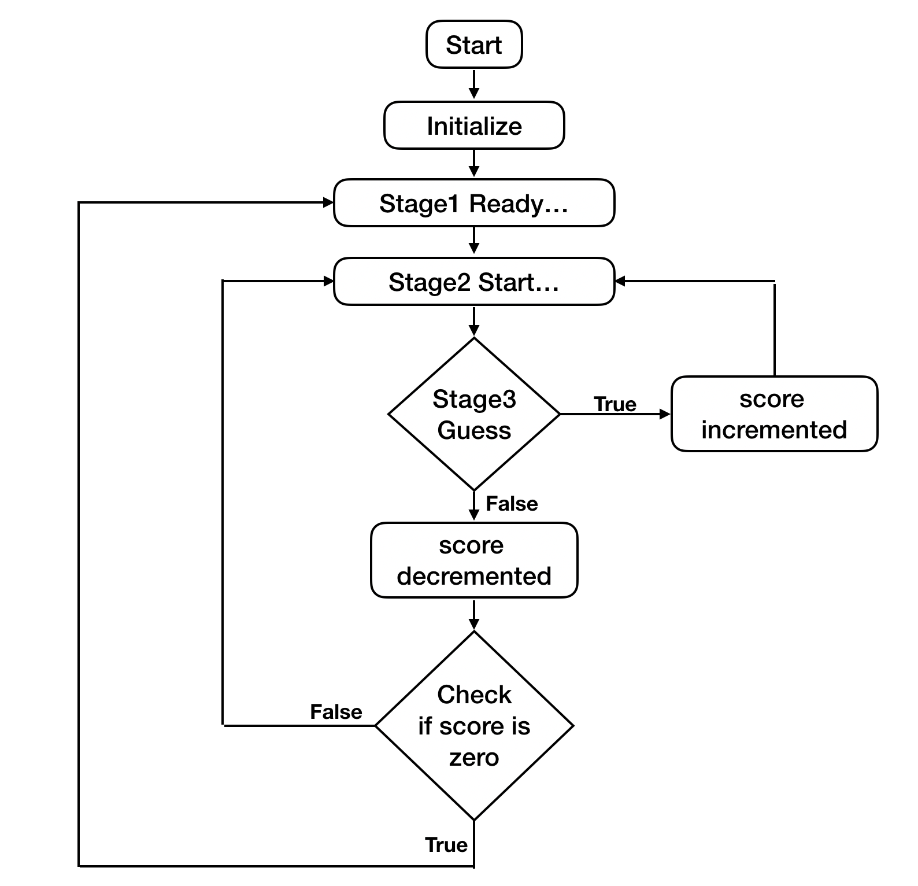

1. **Design Detail**

This part will show details about how to achieve functions.

1.After the simulation system is turned on (i.e. the lab board is powered on), the system is initialized and the ball is with an arbitrarily cup. In this case,

a. “Ready…” is displayed on LCD;

b. The cup LED with the ball is on, as illustrated in Figure 3 (a), where the ball is with Cup 3. Other LEDs are off.

*In reset part, system initialize all the registers, I/O ports, LCD, keypad, and interrupt. The* [*initial*](https://www.bing.com/dict/search?q=initial&FORM=BDVSP6&mkt=zh-cn)[*position*](https://www.bing.com/dict/search?q=position&FORM=BDVSP6&mkt=zh-cn) *of ball can be defined by an undefined register, because it will potential drift and choose the reminder of this register value divide three to be the cup number, also ball position will change randomly soon in next stage.*

2. When the push button is pressed, the game starts and the ball is shuffled under the three cups. In this case,

a. “Start …” is displayed on LCD;

b. Motor spins;

c. Three cup LEDs are all on, but in dimmed light; other LEDs remain off, as shown in Figure (b).

*Use button to interrupt and stage from 1 to 2. In last part of stage2 is a loop to create a random position to store the ball. In this loop part, the clock time of each position is quite same to make sure it happens randomly.*

*Put proper delay between full light and full darkness to make the LED in dimmed light.*

3. When the player wants to make a guess for the ball position by pressing the push button again, the ball shuffle stops. In this case,

a. The motor stops;

b. The three cup LEDs remain dimmed, as shown in Figure (3)(b);

c. After the player keys in the ball position on the key pad, the cups are removed, the ball position is uncovered and the score is determined. In this case,

i. The cup LED with the ball is fully on, as illustrated in Figure 3 (c), where the ball is now with Cup 2;

ii. If the player’s guess is correct, the score on the LCD is incremented by 1 and the indicator will flash a few times, as illustrated in Figure 3 (c)(i); otherwise,

iii. If the guess is incorrect, as illustrated in Figure 3 (c)(ii), the score on LCD is decremented.

*Use the button as interrupt to add stage_flag to 3 making the system to stage 3. Read the output of keypad, if the output is not 1, 2 or 3, return to the keypad loop and wait for another valid input. After get valid input, compare with ball position, if same, increase score, otherwise, decrease it. Before display score, change it to ascii value.*

4.When the player’s score becomes zero, the game will be reset to the initial start status; otherwise, the game can be continued by pressing the button for a new round of ball shuffle.

*Check score before display, if is less than 1, display ‘GAME OVER!’ and jump to reset. If not, stay in stage 3 until another interrupt occur and system come to stage 2.*